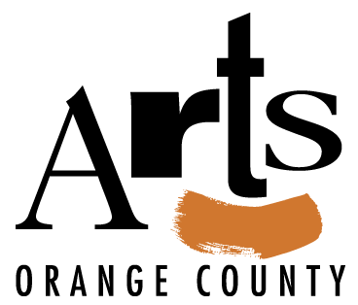
FOR IMMEDIATE RELEASE
Contact: Richard Stein, rstein@artsoc.org

Announcing Orange County’s Poetry Out Loud Champion:
Elora Sparnicht of Irvine, a Student at OCSA

Elora Sparnicht of Irvine, a junior at Orange County School of the Arts in Santa Ana, has won the 2022 Poetry Out Loud competition for Orange County. Sparnicht’s winning recitations were “Cartoon Physics” by Nick Flynn and “Invisible Children” by Mariana Llanos.

Orange County Poetry Out Loud (https://artsoc.org/events-and-programs/poetry-out-loud/) is a collaboration of Arts Orange County and the Orange County Department of Education. Eight schools and three community organizations participated in the program, with an estimated 500 students competing. Five finalists competed in the Orange County Poetry Out Loud championship.

The 2nd-place title was awarded to Emily Dang representing La Quinta High School in Westminster. The 3rd-place honor went to Charlotte De Leon of Mater Dei High School in Santa Ana.

Poetry Out Loud is a national arts education program that encourages the study of great poetry by offering free educational materials and a dynamic recitation competition for high school students across the country. This program helps students master public speaking skills, build self-confidence, and learn about literary history and contemporary life.

Elora will compete against the winners from other counties in the statewide competition coordinated by the California Arts Council, a state agency, in March (https://www.capoetryoutloud.org/). The statewide winner will compete in the national competition coordinated by the National Endowment for the Arts, a federal agency (https://www.poetryoutloud.org/).

This season’s Poetry Out Loud program and competition persevered through a worldwide pandemic presenting extraordinary opportunities and unique challenges. This was the second year the competition included the participation of community organizations as well as local high schools, providing a wider range of inclusion for all local students. Program participants had several weeks to memorize two poems from the National Poetry Out Loud anthology, record those poems and submit them to the county's panel of judges.

This season’s guest judges included well-known Southern California poet and writers Professor Marcus “Judah 1” Oliver (Pitzer Colleges, Pomona), Danielle Mitchell (The Poetry Lab) and Sara Guerrero (Breath of Fire Latina Theater Ensemble). Poetry recitations were scored based on physical presence, voice and articulation, dramatic appropriateness, evidence of understanding, overall performance and accuracy. All judges' scores were tabulated and a special showcase and open mic was held online February 12 to celebrate all of the season’s participants.

The Orange County Poetry Out Loud coach was Marcus Omari (http://www.marcusomari.com/), a poet, performer, teacher, and founder of the Poetic Reform Party, an organization dedicated to promoting literacy, expanding the poetic arts, strengthening the communities artists call home, and bending the horizon of our shared social landscape toward a brighter future.

Those high schools or organizations interested in participating in next season’s Orange County Poetry Out Loud competition, should visit https://artsoc.org/events-and-programs/poetry-out-loud/ for information, which will be updated later this year.

Arts Orange County is the leader in building appreciation of, participation in and support for the arts and arts education in Orange County, California. An independent nonprofit organization, it is designated the official Local Arts Agency and State-Local Partner of the County of Orange by the Board of Supervisors. In addition to offering traditional arts council programs and services, Arts Orange County is an innovator in the field in playing a “go-to” role as a consultant to local government in the areas of cultural planning and public art management. For more information about Arts Orange County, visit https://artsoc.org/.

The Orange County Department of Education (OCDE) is a public education organization offering support services to 27 school districts and more than 600 schools and 20,000 educators serving over 500,000 students in Orange County. OCDE's personnel offer support, professional development, and student programs through its divisions and departments. Information about OCDE’s Arts programs and services may be found here: https://ocde.us/EducationalServices/CurriculumInstructionandAcademicEnrichment/ArtsAdvantage/Pages/default.aspx.

###

